Cash Management Training
Use this synthetic job aid to verify the local converter. No real customer data is present.

Review a bank statement
- Step 1: Open the Cash Management workspace.
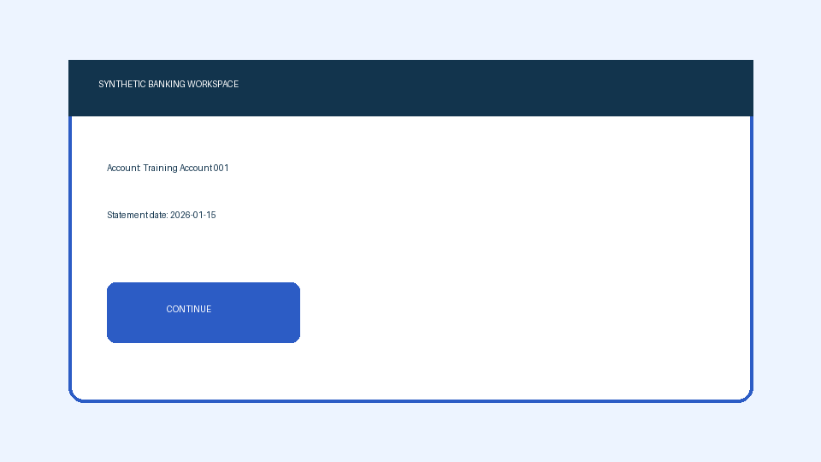
- Step 2: Select Training Account 001.
- Confirm the statement date.
Field | Expected value
Account | Training Account 001
Status | Ready
Quick Tip: Compare the date before continuing.

